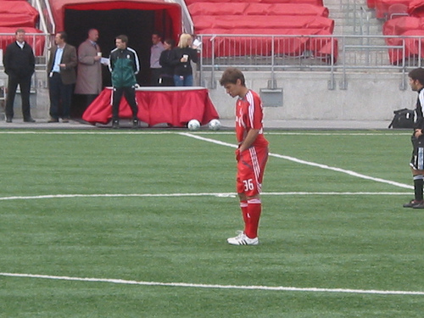
Kilian Elkinson

Born: April 2, 1990

Nationality: Irish/Australian
Position: Left Back
Height: 5’9
Weight: 155lbs

Teams:

2009 Maccabi Canada Open Mens Team – Coach: Salim Brahimi
2008 Toronto F.C. – Manager: Mo Johnston, Coach: John Carver
2008 University of Toronto – Coach: Anthony Capotosto
2007 Bermuda U23 National Squad (Training, offered place)
2005-2008 Upper Canada College (Captain/MVP) – Coach: Premek Hamr
2006-7 CAIS Trophy Champions
2006 OFSAA AAA Silver Medalists
2005-8 CISAA League Champions
2005 Mississauga Dixie ‘89ers Under 16 – Coach: Kerry Baratouglou
OYSL League Champions
Woodbridge Showcase Champions
Ontario Cup Finalists
2003-2005 Bermuda National Youth Squads – Coach: Kenny Thompson
2004-2005 Saltus Grammar School First Team – Coach: John Beard
2001-2005 North Village C.C. (Various Teams) – Coach: Maceo Dill
1997-2000 Pembroke Hamilton C.C. (Various Teams (MVP)) Coach: Jack Castle
1995-1997 B.A.A. (Various Teams)
Other:

2006 Brusa Soccer College (Summer (Florida and Brazil)) Coach: Thadeu Goncalves
2001-2004 Scholarship recipient from and graduated School Of Excellence and Elite program (Bermuda)
  - Bascome/Goater Pro Soccer Clinic (Awards: Shot Accuracy, Dribbling, Juggling, Speed, MVP)

